**Revenue Dashboard Project Report**

**Context:**

1. **Executive Summary**
2. **Project Objectives**
3. **Data Collection & Sources**
4. **Revenue Dashboard Overview**
5. **key Insights & Recommendations**
6. **Conclusion**

**Title:** Revenue Analysis Dashboard

**Prepared by:** Dinesh reddy Kommi reddy

**Date:** 01-02-2025

**Abstract**

This report presents an interactive dashboard analyzing revenue patterns for , providing key insights into sales trends across different time frames. The dashboard visualizes revenue distribution between weekdays and weekends, offering a comparative analysis of customer purchasing behavior. Additionally, it highlights monthly revenue trends to identify seasonal fluctuations and growth patterns. The analysis also includes a ranking of top-performing products, helping to pinpoint bestsellers and optimize inventory management. By leveraging these insights, the store can make data-driven decisions to enhance sales strategies, improve stock planning, and maximize revenue potential.

1. **Executive Summary:**

This project aims to analyze revenue trends for [Toy Store Name] using an Excel dashboard. The dashboard provides insights into sales performance across different time frames, including weekday vs. weekend sales, monthly trends, and top-selling products. The findings will help optimize sales strategies and inventory management.

2. **Project Objectives**

* Identify revenue variations between weekdays and weekends.
* Analyze monthly revenue trends to detect seasonality.
* Determine the top-selling products to optimize inventory.
* Provide a user-friendly dashboard for data-driven decision-making.

**3. Data Collection & Sources :**

* Sales Database
* The Data Field In DataFrame(Sales):
  + Sales_ID
  + Date
  + Day Type
  + Store_ID
  + Unit
* The Data Field in DataFrame(Product):
  + Product_ID
  + Product_name
  + Product_category
  + Product_cost
  + Product_price

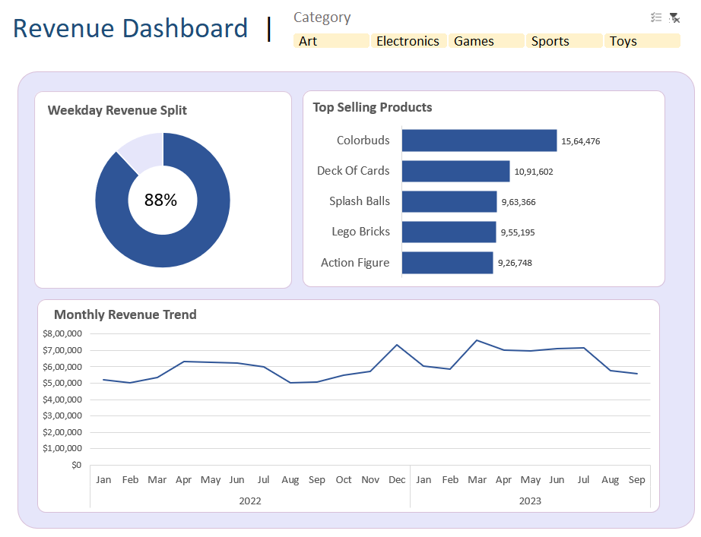

**4. Revenue Dashboard Overview**

**1. Weekday Revenue Split**

* **88% of revenue is generated on weekdays, with a small portion coming from weekends.**
* **The donut chart visually represents the weekday revenue dominance.**

**2. Top Selling Products**

**The highest revenue-generating products are:**

1. **Colorbuds - 15,64,476**
2. **Deck of Cards - 10,91,602**
3. **Splash Balls - 9,63,366**
4. **Lego Bricks - 9,55,195**
5. **Action Figure - 9,26,748**

**Colorbuds contribute the highest revenue.**

**3. Monthly Revenue Trend**

* **Revenue fluctuates over time, showing a steady increase from January to May, peaking around April.**
* **A slight dip in mid-year but recovery toward year-end before declining again in August-September 2023.**
* **The highest revenue months appear to be April and May in both 2022 and 2023.**

**4. Category Selection**

* **Users can filter revenue data by selecting Art, Electronics, Games, Sports, or Toys categories.**
* **The current selection highlights multiple categories in a soft yellow shade.**

**5. Key Insights & Recommendations**

✔ **Weekday Sales Focus**: Since 88% of revenue is generated on weekdays, businesses should enhance weekday marketing efforts, such as promotions and targeted ads. ‘

✔ **Product Performance**: Colorbuds is the best-selling product, and further investment in its marketing and inventory management can maximize profits.

✔ **Seasonal Revenue Trends**: The peak in April-May suggests potential seasonal demand, which should be capitalized on with promotions or stock adjustments.

✔ **Declining Revenue in August-September**: Investigate factors causing this decline, such as market trends, seasonality, or competition.

✔ **Category Performance**: Further segmentation analysis can help determine the strongest and weakest-performing categories.

**6. Conclusion**

The Revenue Dashboard provides valuable insights into sales trends and consumer behavior. By focusing on weekday sales, optimizing best-selling products, and addressing seasonal fluctuations, businesses can drive higher revenue growth and improve overall financial performance.